**Python_Problem_Statement_7_Anup_Patil**

**Write a Python program to count the number of even and odd numbers from a series of numbers.**

Sample numbers : numbers = (1, 2, 3, 4, 5, 6, 7, 8, 9)

Expected Output :

Number of even numbers : 4

Number of odd numbers : 5

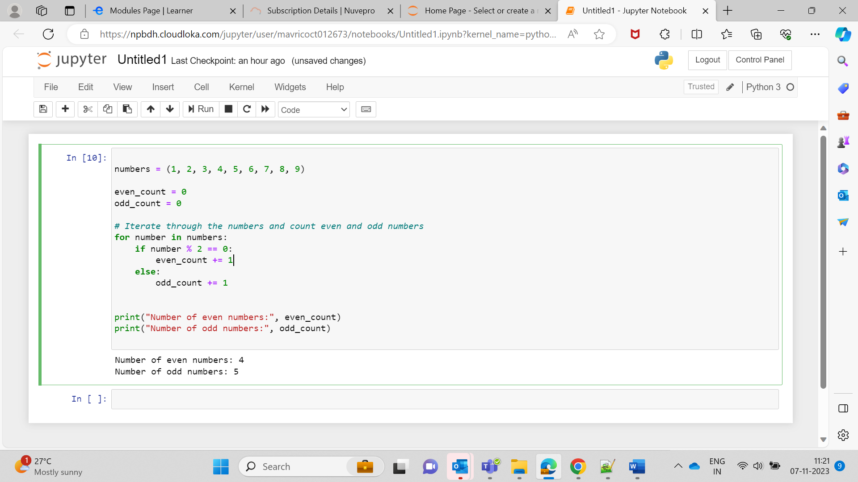

numbers = (1, 2, 3, 4, 5, 6, 7, 8, 9)

even_count = 0

odd_count = 0

# Iterate through the numbers and count even and odd numbers

for number in numbers:

if number % 2 == 0:

even_count += 1

else:

odd_count += 1

print("Number of even numbers:", even_count)

print("Number of odd numbers:", odd_count)